PROJECT PROPOSAL

**INTRODUCTION**

**Problem**

**Solution**

**Visual Aid**

**High Level Requirements**

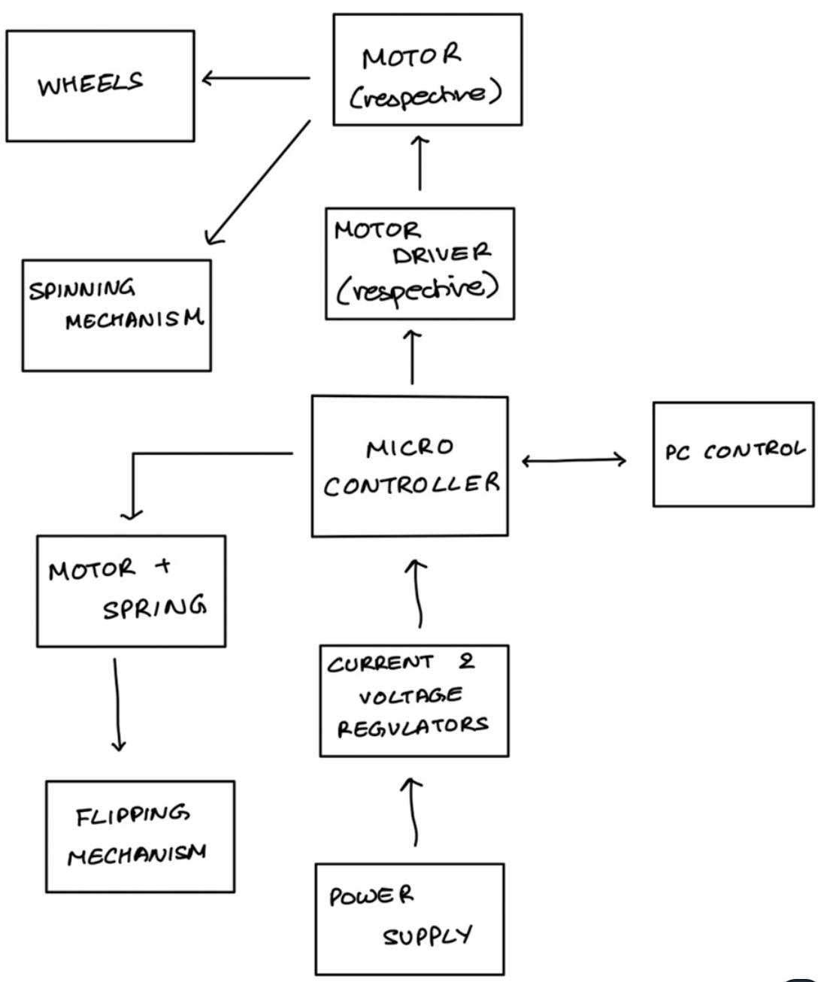

**DESIGN**

1. Wheels
2. Beyblade Spinner
3. Flipping Motion
4. Microcontroller
5. Tolerance Analysis
6. Battery

MICROCONTROLLER

ESP32 better than Arduino   
  
Because

* Has built in modules for wifi and more pins so more connections can be made to the

Questions  
 - for the flipping motion, do we use a servo motor + gear or a servo motor + spring

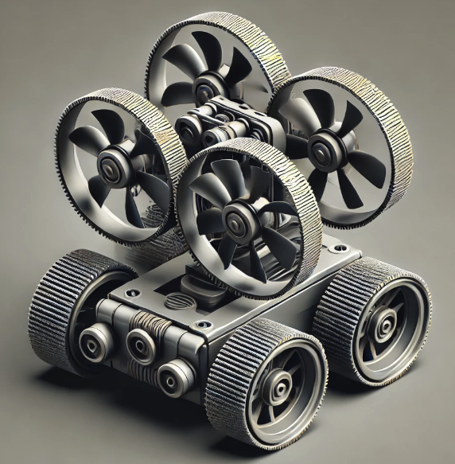

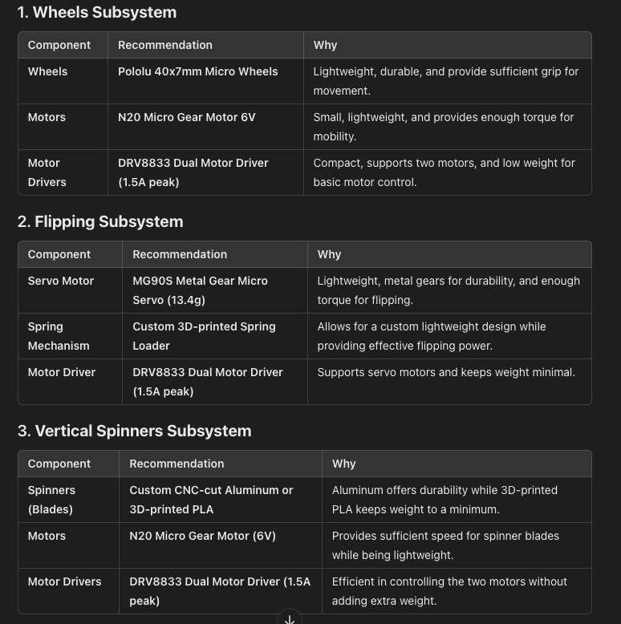

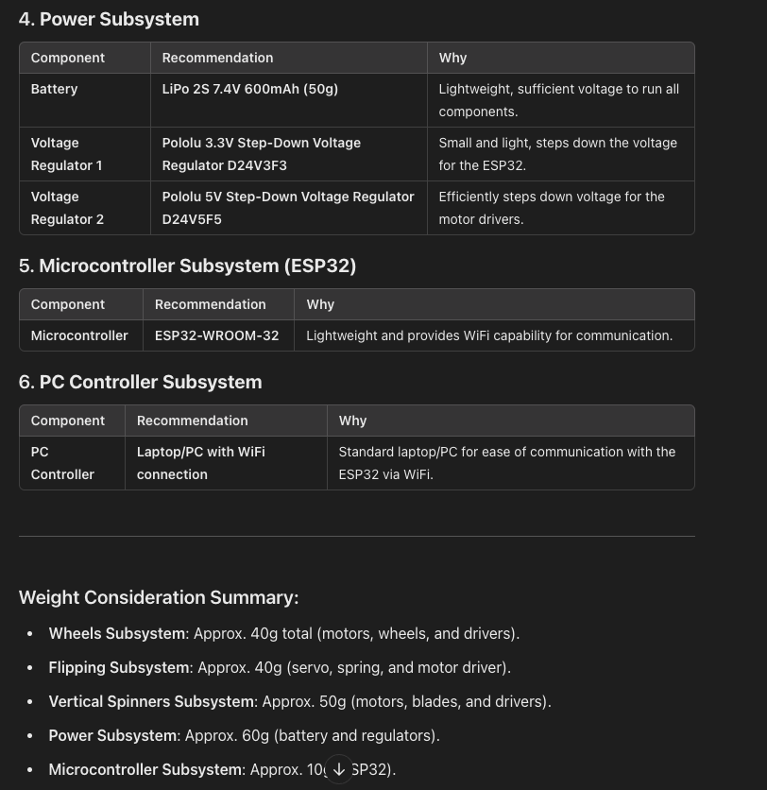

Total weight approximation: **200g-250g**, leaving room for the chassis and structural components to stay under the 2-pound limit.

Each component is chosen to balance functionality and weight to keep the battle bot agile and competitive within the 2-pound weight limit.

* Do we need a circuit breaker

The objective of this project is to design and develop a battlebot that can be remotely controlled from a PC and is capable of competing against other battlebots in a confined arena. The key goal is to build a battlebot that meets competition guidelines, is agile, durable, and equipped with offensive and defensive mechanisms to outperform opponents.

Battlebot design must follow strict material and mobility specifications like the following:

* Only the following plastic materials are allowed for the chassis and fighting tool: PET, PETG, ABS, PLA, or PLA+.
* Chassis and fighting tools must be 3D printed.
* Motors, electronics, axles, fasteners, and adhesives can be made from any material.
* These components cannot be used to enhance the robot’s structural integrity, armor, or fighting tool.
* Maximum total weight of the robot is limited to 2 pounds.
* Approved locomotion for this design includes rolling mechanisms, specifically wheels, which will provide continuous motion driven by motors.
* Methods such as flying, jumping, or hovering are strictly prohibited.
* The battlebot will be controlled wirelessly via Wi-Fi.
* A custom-designed PCB will house the microcontroller that facilitates communication between the robot and a PC.
* The Wi-Fi connection must be programmed to prevent interference with other participants' robots.
* In case of lost Wi-Fi connectivity, the robot will automatically enter shutdown mode, stopping all movement and deactivating the fighting tool.
* The battlebot will use Li-po batteries for power.
* Batteries must be sealed and non-spillable, with a maximum voltage of 16V.
* Battery terminals must be protected from shorts to prevent fires.
* The robot must have an external light indicating when the main power is on and a secondary light to signal an active Wi-Fi connection.

1. **Control and Communication System:** The ESP32 microcontroller communicates with the PC via Wi-Fi to receive keyboard input and control all subsystems (Wheels, Vertical Spinners, and Flipping Mechanism). The ESP32 acts as the central hub for controlling the robot's overall functionality.
2. **Subsystems for Movement and Combat:**
   * **Wheels Subsystem**: Two wheels are driven by two separate motors, each controlled by its own motor driver (Motor Drivers 1 and 2).
   * **Vertical Spinners Subsystem**: Two spinners are controlled by a single motor, which is managed by Motor Driver 4.
   * **Flipping Subsystem**: The spring-loaded flipper is controlled by a servo motor (Motor 3), driven by Motor Driver 3.
3. **Power Management and Line Color Meanings:**
   * **Red Lines**: Represent power supply connections from the **LiPo battery (12V)** through the kill switch to the motor drivers and voltage regulator.
   * **Blue Lines**: Represent the control signals sent from the motor drivers to the motors and spinners.
   * **Orange Lines**: Represent communication signals between the **ESP32 microcontroller** and motor drivers for controlling all movement and combat actions.

<https://connbots.weebly.com/blog/a-1-lb-spring-powered-flipper-the-complete-journey>